Shabbos Stories for
Parshas mishpatim 5781
Volume 12, Issue 24 1 Adar/February 13, 2021
Printed L’illuy nishmas Nechama bas R’ Noach, a”hs

For a free subscription, please forward your request to keren18@juno.com
Past stories can be found on the website ShabbosStories.com

Surprising the Spy
By Eitan Lev

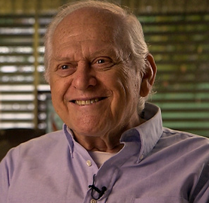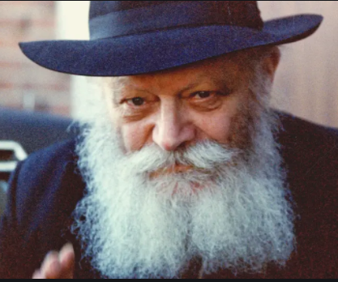
Mr. Eitan Lev and The Lubavitcher Rebbe, zt”l

For close to twenty years, during the 1960s and 1970s, I was stationed in New York, serving in a senior position with the Mossad, Israel’s intelligence agency.
During one of these years — I believe that it was in the end of 1967 — a few of my colleagues at the Israeli consulate in New York invited me to join them on an excursion to Brooklyn. They explained that they were going to visit the Lubavitcher Rebbe’s synagogue to participate in the celebration of Simchat Torah there.
“Who? What? What is this about?” I asked, but they assured me that it would be a very nice, festive event. “Can I bring my wife?” I asked, and to my delight they said that she could join. I was so totally unprepared for where we were going and what was going to happen.

We Saw a Big Commotion
When we got to Chabad Headquarters, we saw a big commotion. It turned out that the hakafot — the dancing with the Torah — had not yet begun, but a farbrengen with the Rebbe was taking place, and it seemed that the place was too small to accommodate the thousands of chasidim who had shown up. However, our visit had been arranged in advance, and seats had been saved for us inside.
We were led into the big hall where the excitement was palpable — the crowd was singing with great joy, and the Rebbe was beating out the rhythm on his table.
Suddenly a chasid approached me, saying, “The Rebbe would like to speak with you.”
I was very surprised. The Rebbe? Speak to me? How does the Rebbe even know who I am?
“There must be a mistake,” I said. But he insisted that the Rebbe wanted to converse with me.
I turned to my colleagues and asked if anyone had informed the Rebbe’s secretariat that I would be coming. Of course, due to my position, I always made sure to keep a low profile. No one was supposed to know my identity nor my location. But they all shrugged their shoulders, as if to say, “We didn’t say a thing. We have no idea what this is about.”

Led to Where the Rebbe was Sitting
I was led to the platform where the Rebbe was sitting. “It is nice to see you here,” he greeted me, speaking Yiddish. Beyond the surprise of being summoned to the Rebbe, I was shocked that he was talking to me in Yiddish.
“How do you know that I speak Yiddish?” I asked the Rebbe.
I realize that it was audacious of me to interrogate him like that, but he just smiled and began to shower me with blessings that I should succeed in the work that I was doing, that I be healthy and have a good livelihood. “Be careful and take care of yourself. Your job is very important for the Jewish people,” he said.
As a member of the Mossad, I suddenly felt very exposed. I was bewildered and didn’t understand what was going on. I was not used to being surprised — usually the only surprises that I experienced were the ones that I had orchestrated myself. So I was convinced that my colleagues had told the Rebbe about me. They must be lying to me, I thought. After all, they are trained experts at hiding the truth! I resolved to take care of them later.
Then the Rebbe began to ask me about my family. He asked me about my father, about my mother, and about my sister. How did the Rebbe even know that I had a sister? He also asked me about my wife and children. I told him that my wife came with me, and he responded, “Yes, I know. She is sitting with the women upstairs.”
Of course, my wonderment only grew. It started to feel like someone was mocking me. Maybe the connection between the consulate and the Rebbe ran so deep that they worked together to play a prank on me. I simply didn’t know what to think.

“How Do You Feel as a Jew?”
Another question that the Rebbe asked me was, “How do you feel as a Jew?” I assume that he was asking me this because I didn’t look Jewish, which was one of the reasons that I was able to work in intelligence. But I felt Jewish in every fiber of my being, and I told the Rebbe so.
He then asked me how it felt to travel the world as a Jew.
I answered that, while stationed in the United States, I made sure to send my children to a Jewish school. As far as keeping kosher, I have been careful in this regard my whole life, and when my work put me in a challenging situation, I avoided non-kosher foods by claiming to be vegan.
I don’t know exactly how long this conversation with the Rebbe continued, but I am certain that it seemed longer to me than it actually was. I felt that I was standing there for at least a half hour, but it must have been much less, probably just a few minutes. At a certain point, sensing that the whole crowd was waiting for me to finish, I started to feel uncomfortable. So I tried to wrap up the conversation by saying, “We have been speaking for a long time and everyone is waiting…”
I know this was another audacious statement on my part — who was I to be telling the Rebbe what to do — but he was in no rush to finish talking.

The Rebbe Blessed Me
At the end, the Rebbe gave me a piece of cake and then blessed me again that I should succeed in everything I do and that I should be healthy and strong. This blessing held special meaning for me because I had gotten injured a few times during my service.
As I made my way back to my seat, everyone along the way asked me for a small piece of the Rebbe’s cake, so that by the end, I had barely a few crumbs left.
When I reached my colleagues I demanded, “Guys, what’s going on here?” But they seemed just as puzzled as I was.
I continued to interrogate them the next day until they finally convinced me that none of them had spoken to the Rebbe or his secretariat about me. So I still do not understand how the Rebbe knew that I spoke Yiddish, or how he knew what I was doing. And my sense was that he knew even more than he revealed.
All this was very strange for me. Was I so transparent? That would pose a serious problem. But, if I really was so transparent, why couldn’t everyone see it? Why only he?
These questions were on my mind for a long time and I didn’t find any answers until I met a Chabad chasid who explained it to me in three words: “That’s the Rebbe.”

Impressed Fifty Years Later by the Experience
The fact that until today, more than fifty years later, this event is still engraved in my memory is testimony to how impressed I was by the experience. I left feeling that I met a brilliant man, with vast knowledge and understanding, and exceptional analytical thinking power. I also learned from the Rebbe how to listen. When he asked me something and I answered, he was silent, letting me speak while he listened attentively.
He was an outstanding person, one in a generation. There is a lot to learn from him, and I feel too small to truly understand this great man. I was fortunate to meet a true leader, and I thank G-d for that.
Mr. Eitan Lev served in the Mossad for many years. In the 1960s and 1970s, he filled confidential positions in North America and South America. He was interviewed in his home in Tel Aviv, in December of 2013.

Reprinted from the Erev Shabbat Parshat Shemot 5781 email of the Jewish Educational Media’s “Here’s my Story.”

The Healer of All Flesh
By Zelda Goldfield
As the number of infected and deceased leaped up dramatically at the summer’s end – together with a commensurate increase of protests, strikes and Covid-deniers – our [Israeli] government decreed the Tishrei lockdown. Now everything was closed, except for supermarkets and medical facilities. No one was allowed to stray more than one measly kilometer from their home.
The lockdown was a necessary but tortuous measure. Parents lost patience with their home-schooled children and store owners lost their businesses. Of course, the growing loss of lives was the most excruciating and frightening for all.
But even non-life threatening losses that the lockdown caused, such as not being able to see your grandchildren, forfeiting your daily swim, being deprived of a wedding with more than 10 guests, not being able to participate in a close relative’s funeral, or failing to reach Uman for Rosh Hashanah, were agonizing for the people to whom these activities were crucially important.
For my husband and I, not being able to daven at the Kotel every Wednesday morning as we had done for many years was agonizing. My daughter attempted to reach the Old City from Bayit Vegan and a kind policemen sent her home and graciously did not issue a fine. My neighbor’s son was not so lucky. He and his little boy were each fined 500 Shekels. As law abiding citizens, we didn’t even try.

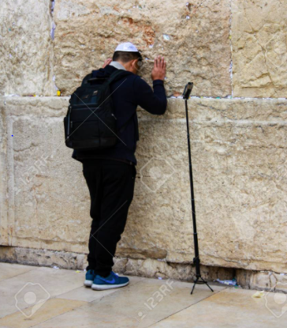

Yet a friend who recently retired and came on aliyah did venture out. Ever since he had settled in the holy city of Jerusalem, he made the commitment to daven at the vasikin weekday minyan at the Kotel every morning. So on the first day of Chol HaMoed, he jumped into his car at 4:20 a.m. and drove to the Old City. A policeman promptly stopped him at Jaffa Gate.
“Do you live here in the Old City, mister?” the policeman asked.
“No, I live in Ramat Eshkol.”
“Then what are you doing here, outside the kilometer limit?

“I’m Going to My Doctor”
“I’m going to my doctor, that’s allowed according to the rules, isn’t it?” he replied without batting an eyelid.
“Your doctor? Really! At 4:30 in the morning? C’mon. Who d’ya think your kiddin?” the policeman chuckled as he flourished his pad of ticket forms and eased his pen out from behind his left ear.
“Yes, really,” he retorted indignantly. “I am telling you the truth. I am on my way to the Kotel to daven to He who heals all flesh – rofeh kol basar!”
The policeman grinned, moved aside, and waved him in.

Reprinted from the January 8, 2021 edition of The Jewish Press.
The Unlikely Bandit
By Elchonon Isaacs

Illustrated by the Rivka Korf Studio

In the town of Zhytomyr, where the venerable Rabbi Zev Volf led the community, things had gone wrong one too many times in the kosher slaughterhouse. Each time the source was the same: the carelessness of the shochet, who did not seem to appreciate the importance of his job and the weighty responsibility it entailed.
Feeling he had no choice, Rabbi Zev Volf forbade the shochet to continue slaughtering animals in the city. At first, the deposed shochet accepted the ruling, but as time passed a thought crossed his mind: “The rabbi only revoked permission to slaughter in the city of Zhytomyr but never prohibited me from slaughtering in the countryside. I will travel there and offer my services wherever needed.”
With a hopeful heart, he took his bag of chalafim (slaughtering knives), some food and clothing, and began his trek. Upon arriving in a small village, he went to the local inn that was managed by a Jew. After praying, he turned to the wife of the innkeeper and offered his services. To his dismay, she said the regular shochet had already passed through earlier that morning and done the work.
The deposed shochet sighed and continued on his way, trudging through the forest, feeling hopeless and downhearted. As the sun set, a band of robbers surrounded him. They tied him up and dragged him to their hideout.
A thought popped into his mind, and he said to his captors, “Why would you treat one your own like this?” Seeing that they were caught by surprise, the shochet smiled and explained, “I am also in this business. I am certain I can be a useful member of the gang,” and he pointed to his bag of slaughtering knives. His captors’ eyes lit up when they saw the sharp weapons. They immediately untied him, accepted him into their ranks, and set him to work polishing their daggers.
Initially, his conscience weighed on him and he constantly thought of escape, but the right opportunity never arose. With time, he began to mimic his newfound friends, and the former shochet morphed into a remorseless bandit, a full-fledged member of the team.

Years passed.
One morning at dawn he waited for prey at a crossroads leading to the city of Mezhyrichi. A small carriage passed by and he pounced on the passenger, dragged him deep into the forest, and demanded his money. The captive took out his torn pouch and handed over the few coins he had. The disappointed robber drew his sword to kill the poor soul.
The captive looked at the bandit with pleading eyes and begged, “I am in your hands; do to me as you wish. But please grant me one final request. Allow me to wash my hands according to Jewish tradition, recite my morning blessings, read the Shema prayer, and recite the final confession.”
The bandit agreed and the captive washed his hands and began to chant the morning Modeh Ani slowly and emotionally. “My G-d, the soul that You have placed within me is pure, You created it; You formed it; You have breathed it into me, and You preserve it within me. And You will take it from me in the future…”
Engrossed in his prayer, he did not notice the change coming over his captor. The bandit was pale, sweat beaded on his face, and he began to shake uncontrollably.
The thump of the bandit falling to the ground aroused the captive from his reverie. With the small amount of water he had, he managed to revive him from his faint.
When the captor regained his composure, he managed to utter a few shaky words. “Rebbe, do you recognize me?”
Tears flowed from his eyes.
“I was once the shochet of Zhytomyr, whom you deposed many years ago.”
Reb Zev Volf was astonished. “How did you get here? How did you fall so low?”
The bandit recounted the events that had led him to this point, and a new wave of tears flowed down his face. “Rebbe,” he cried, “I want to return. Is there a way back for me?!”
“The gates of teshuvah are never closed,” Reb Zev Volf replied. “The first step is to stop transgressing. Leave everything behind you. Leave this dark place and let’s travel together to my teacher, the Maggid of Mezhyrichi. I am certain he will see the depth of your broken soul and will find a way to help you.”
The bandit agreed and they continued on to Mezhyrichi together. After hearing the erstwhile shochet’s history from Reb Zev Volf, the Maggid summoned him and prescribed a path to spiritual healing. It was a difficult process, but he accepted it with love and joy.
The time he spent in repentance was not very long, as he soon passed away. Very few people attended his funeral. Reb Zev Volf led the procession with a bowed head, and in his eulogy he noted how the man’s tragic trajectory had come about by his own doing, as he did not follow the Sages’ directive, “Be cautious in judgment.”¹
FOOTNOTES
1. Avot 1:1.

Reprinted from the Parshat Va’eira 5781 email of Chabad.Org Magazine.

No Coincidences

Rabbi David Ashear writes in his book Living Emunah: On the Parasha that one of the main reasons Hashem took the Jews out of Egypt in such a miraculous way was to teach us that Hashem is behind all miracles, both large and small. Rabbi Ashear recounted a story he read in Sefer Emunah Shelemah about a religious man named Daniel, who traveled to Russia on a business trip.

Connecting with the Russian Taxi Driver
While in a taxi there, Daniel was listening to Hebrew music through his headphones and sang along in a low voice. The driver, who looked like a non-Jew, said, “I know that language! It’s Hebrew, right? My mother speaks some Hebrew.” Daniel was intrigued. “Does she live nearby? I’d like to meet her.” The driver took Daniel to his mother’s house.
Daniel spoke a little Russian and, after some small talk, asked the driver’s mother how she came to live in Russia. She related she had managed to escape Europe with her son, and they ended up in Russia, but her husband and daughter passed away in the Holocaust.
“Why did you never remarry?” Daniel asked.
“Because there were no Jews here for me to marry! And now that there are, I am elderly. It is too late.”

The Woman’s Amazing Self-Sacrifice
Daniel was amazed by the woman’s self-sacrifice. She had raised a son alone in a foreign country for decades, unwilling to compromise her Judaism and marry out of the faith. Daniel took it upon himself to rekindle the spark in the taxi driver’s soul. He found a shul close to the man’s home and brought him there to meet the rabbi. Eventually, the man became fully observant. By the time his mother passed away, he was learning daily and was able to say kaddish for her.
The story on the surface seems like a nice coincidence. A religious man finds out his driver is Jewish and helps him reconnect to Judaism. Yet, there are no coincidences. Hashem performed outrageous miracles in Egypt, and He orchestrated every seemingly small miracle, like Daniel singing along to Hebrew music in a taxi in Russia.

Reprinted from the Parshat Va’eira 5781 email of Rabbi Amram Sananes as written by Jack E. Rahmey.

The Story of Two Jewish Brothers
By Daniel Keren

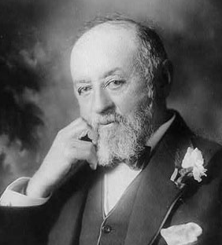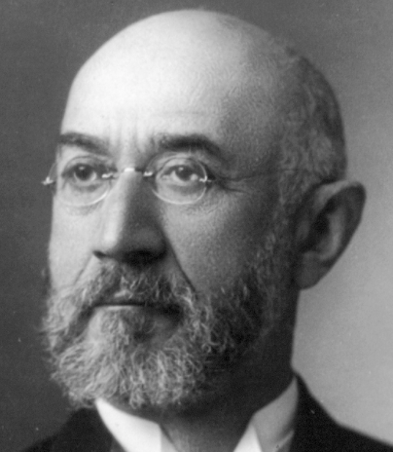
Nathan Straus and Isidore Straus

Rabbi Chaim Aryeh Ginzberg recalled recently reading a magazine article about the Israeli city of Netanya. The story goes back almost 108 years ago to when two Jewish brothers – Nathan and Isidore Straus (owners of Macy’s Department Store in Manhattan and Abraham & Straus Department Store in Brooklyn) decided to take a six-month vacation with their wives touring through Europe.
During their trip to all of the classical sites of Europe, someone asked them if they intended to visit Palestine where many Jews were beginning to create new communities. It wasn’t on their itinerary, but both brothers thought it would be nice to spend a week in the Holy Land that was rich with Jewish history.
During that week, the brothers and their wives travelled to different communities and generously donated to institutions that would help their Jewish brethren. However at the end of the week, Isidore was anxious to resume his European tour. However Nathan wanted to see more of the Jewish settlements and help them with philanthropic donations.
Because of that he missed joining his brother and sister-in-law in returning to America on a special ship making her maiden journey towards America. That ship was the RMS Titanic.
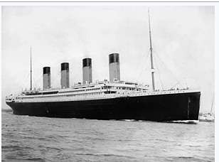
The ill-fated RMS Titanic

One of Nathan’s donations while in Palestine was to helping a fledgling Jewish settlement being created on the Mediterranean Sea. And they honored his donation by naming their community in his honor – Natanya.

The Importance of Just One Small Decision
Rabbi Ginzberg noted that was just one small decision. Should we go or should we stay for a few more weeks? The result was that one brother perished and one survived. Nathan who lived another 19 years spent the rest of his life devoting himself to giving philanthropic donations to Jewish causes in behalf of the memory of his brother and sister-in-law.

Reprinted from the January 8, 2021 edition of the Flatbush Jewish Journal.
Story #1205
The Party Spoiler
From the desk of Yerachmiel Tilles

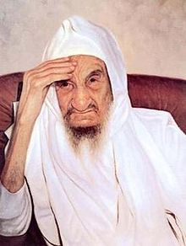

When Baba Sali was the chief rabbi of Boudenib, the city was ruled by a cruel man who loved nothing more than tormenting the Jews.
One day, R. Avraham, an important member of the Boudenib Jewish community, decided that he was going to make an elaborate feast in honor of the city’s ruler, in the hopes that all the compliments and respect that would be poured on this man at the event would help soften his heart toward the Jews.
The day of the feast came, and the ruler arrived at R. Avraham’s home for the great feast. All the leaders of the Jewish community were invited to the event, including Baba Sali.

The Baba Sali Made His Entrance
The party was coming along nicely, with the ruler seemingly enjoying himself very much, when Baba Sali made his entrance into the house. He approached the ruler’s seat -- but then, instead of blessing him, he threw his cane forcefully down on the floor, and in a loud, clear, voice, he began to berate the man for his terrible deeds against the Jews under his governance!
All those who were present turned white with fear, and R. Avraham himself nearly fainted. Everyone was sure that the ruler would pull out his gun and shoot Baba Sali on the spot, or at least send him to jail immediately. And who knew how this would affect the rest of the Jewish community!

The Anti-Semitic Ruler Humbly Apologized
But to their shock, when Baba Sali finally finished rebuking the man, the ruler humbly lowered his head and murmured, “I’m sorry, I’m sorry. I apologize.”
A few days later; this ruler’s son suddenly became very sick. The father rushed to send a message to Baba Sali, asking the holy tzadik to pray for his son’s recovery.
Baba Sali came to the ruler’s home and put the watch that he had received from his saintly brother, Rabbi David, under the patient’s head. “Your son should be better by tomorrow morning,” he said. And so it was!

A Changed Man and Great Admirer of the Tzadik
After these incidents, the ruler became a changed man. He turned into a great admirer of Baba Sali, and he stopped harassing the Jews of the city. His son, who became an important official in Morocco, kept up the strong ties with Baba Sali as well.
Source: Adapted by Yerachmiel Tilles from (a book whose title I can’t find about the great sages and kabbalists of the Abuhatzeira family since the patriarch, Rabbi Shmuel Elbaz-Abuhatzeira 300 years ago).
Biographical note: Rabbi Yisrael Abuhatzeira [1890 - 4 Shvat 1984] known as Baba Sali, was born in Tafillalt Morocco, to one of Jewry’s most illustrious families. From a young age he was renowned as a sage, miracle maker and master kabbalist. In 1964 he moved to Eretz Yisrael, eventually settling in 1970 in the Southern development town he made famous, Netivot, and where, since 1984, his tomb has become one of Israel's most visited pilgrimage sites. A number of collections of stories featuring him have been published, including at least two in English.
Connection: Seasonal -- Saturday night begins the 37th yahrzeit of Baba Sali on the 4th of the Jewish month of Shvat.

Reprinted from the Parshat Va’eira 5781 email of KabbalaOnline.org, a project of Ascent of Safed.

Natan Sharansky’s Sefer Tehillim
By Rabbi Dovid Hoffman

When a person realizes that his life is not in his control but in control of the Almighty, that is when he becomes truly liberated. Shlomo Dror, a professor of physchology told over the following story that he witnessed first-hand.
One morning, Shlomo was in a bakery in Jerusalem and as he stood on line, he realized that he was standing behind Natan Sharansky. He had heard the stories about Sharansky. In 1986, when Anatoly Sharansky, a human rights activist and survivor of nine years of harsh imprisonment in the Soviet Gulag, was released, he was told to walk straight across the bridge leading to his new life.

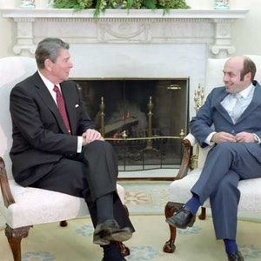
Natan Sharansky meeting former President Ronald Reagan in the White House

A congenital rebel, possessing a courage that most of us cannot imagine, he instead walked in zigzags. That corkscrew walk, each twist representing another challenge surmounted, and of course another challenge to his temporarily disarmed antagonists, was heroism put to motion. And it had legs - it was broadcast around the world, and many of its viewers never forgot it.
Shlomo summoned his courage and introduced himself to Sharansky. He told him that he had just cited Sharansky’s book this week in a class on Sefer Tehillim. He told his students the inspiring story of how the one-time Russian dissident kept a tiny book of Tehillim with him at all times, even when he struggled with authorities to get it back.
Sharansky smiled, reached into his shirt pocket and pulled out that tiny (palm-sized) tattered book of Tehillim. Shlomo asked him, “Do you carry it wherever you go?” Without a pause, he replied, “Actually, it carries me!”

Reprinted from the Parshas Va’eira 5781 email of Torah Tavlin.

Judging Favorably #119
The Unbelievably
Brusque Doctor

A man in Israel had a young child who needed very complicated surgery. The father spent weeks researching to find the right surgeon, amassing the funds to pay for the procedure, and preparing mentally for what lay ahead. Finally, the day arrived. The parents brought their child to the hospital a couple of hours before the operation was scheduled to begin.
The surgeon was supposed to arrive at 7:30, but that time came and went. He was an hour late, then two hours, then six. Nobody in the office knew where he was and he wasn’t answering his phone. The surgery could not be postponed, so the family continued waiting, hoping the doctor would finally arrive.
Toward late afternoon the surgeon walked in. Without a single word of explanation or apology, he brusquely announced that he was ready to begin the surgery and headed for the operating room. Hours later, the doctor returned to the waiting area. “I was successful,” he declared, and turned to leave.
The parents were appalled at his behavior. First, he kept them waiting for over eight hours. Then, when he finally showed up, he offered no explanation for his tardiness. And now, he offered no details about the surgery! The father approached the doctor and berated him for his behavior. The surgeon remained silent and when the father was finished, he just turned around and left.
Later that day, the father found out that the surgeon’s own child had been killed in a terrorist attack very early that morning. He went to the funeral, he sat shivah for an hour and then, like a hero, he went to the hospital to perform life- saving surgery on his young patient.
The father went to R’ Yitzchak Zilberstein for advice on how to rectify what he did. R’ Zilberstein told him, “This doctor is obviously a very good person; he was even willing to come in on that day. Go tell him you’re sorry; he’ll forgive you.” (Living Emunah on the Parashah)

Reprinted from the Parshas Bo 5781 email of The Weekly Vort.

